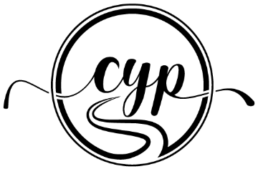

Vision for My Best Life

We each have a vision for our best life. Our vision likely includes our work, relationships, lifestyle, and the way in which we engage in the world. Getting clear on that vision will help us move closer towards it – like directions on a GPS.

Instructions:
- Think about your vision for your best life. What does that look and feel like? When all of the areas in your life are aligned and bring out the best in you, what does that look and feel like? Use the space provided to document your vision for your best life.
- Think about the gap between your current state and your vision that is different? What is causing the gap? Use the space provided to document 1-3 areas in your life that have a gap between your current state and your vision.
- Think about your specific – more detailed – vision for those 1-3 areas in your life. What do you currently love about those areas and what would you like to change? Use the space provided to document your specific vision for each of the areas you have chosen.

In the next activity, the Fuel Gauge Exercise, you will be asked to gauge how close you are to your vision and what is missing. For now, allow yourself to dream about your best life, and document what that looks and feels like in these specific areas of your life.

In my vision for my best life, Click or tap here to enter text.

The areas of focus that will move me closer to my best life are, Click or tap here to enter text.

My specific vision for the first area is, Click or tap here to enter text.

My specific vision for the second area is, Click or tap here to enter text.

My specific vision for the third area is, Click or tap here to enter text.

